FINAL REPORT & DEMONSTRATION ON VIDEO
1. INTRODUCTION:
1.1 Project Overview:
Heart disease remains one of the leading causes of mortality worldwide, and its impact continues to grow due to lifestyle changes, poor dietary habits, and lack of physical activity. Despite advances in medicine, prevention and early detection remain critical in reducing the risk of severe outcomes. However, analyzing large-scale health data related to heart disease—such as patient demographics, medical history, lifestyle choices, and clinical indicators—requires advanced tools for extracting insights.
In this project, we aim to use Tableau as a powerful data visualization and business intelligence tool to analyze heart disease data. The goal is to transform raw data into meaningful dashboards, highlight key risk factors, and identify correlations that can support better decision-making for healthcare providers, policymakers, and individuals. By leveraging Tableau’s interactive visualizations, the project seeks to uncover hidden trends, compare patient groups, and tell stories through data that aid in preventive care and awareness.
Scenario 1
Dr. Sharma is a senior cardiologist working at a metropolitan hospital. She wants to understand which lifestyle factors contribute most to the increase in heart disease cases among middle-aged patients. Using Tableau dashboards, she can analyze patient data segmented by age, gender, BMI, cholesterol levels, and smoking habits. This helps her identify high-risk groups and design targeted awareness campaigns, such as advising patients on weight management and smoking cessation programs.
Scenario 2
Ramesh works with a government health department and is tasked with developing preventive health policies. He uses Tableau dashboards to study trends in heart disease prevalence across different regions, comparing rural and urban populations. By analyzing correlations between sedentary lifestyle indicators and disease rates, he can recommend policies such as fitness programs in workplaces, stricter tobacco regulations, and subsidies for healthier food options. Tableau helps him present these findings in interactive dashboards for decision-makers.
Scenario 3
Anita, a 45-year-old professional with a family history of heart disease, wants to monitor her health risks. With simplified Tableau dashboards provided by her healthcare provider, she can visualize her risk factors such as cholesterol levels, blood pressure, and lifestyle habits compared to healthy benchmarks. The dashboard highlights actionable steps like increasing physical activity or reducing fat intake. This empowers Anita to make informed decisions about her lifestyle and proactively reduce her risk of developing heart disease.

1.2 Purpose:
The primary purpose of this project is to convert complex, large-scale heart disease data into clear visual stories that help people make better health decisions.
By using Tableau, the project bridges the gap between raw medical numbers and actual real-world action across three distinct levels:
1. Improving Clinical Care (The Doctor)
- Purpose: To help medical professionals quickly spot which combinations of lifestyle habits (like smoking combined with high BMI) pose the highest danger.
- Result: Doctors can design sharper, targeted health campaigns for their specific patient groups.
2. Shaping Public Policy (The Government)
- Purpose: To give health departments a macro-view of where heart disease is striking hardest and why.
- Result: Policymakers can back up requests for funding, workplace fitness rules, or tobacco restrictions with clear visual proof.
3. Empowering Individual Patients (The Citizen)
- Purpose: To strip away confusing medical jargon and show individuals exactly how their daily choices affect their lifespan.
- Result: Regular people can see their own health risks compared to safe benchmarks, motivating them to change their diet and exercise habits.

2. IDEATION PHASE:
2.1 Problem Statement:
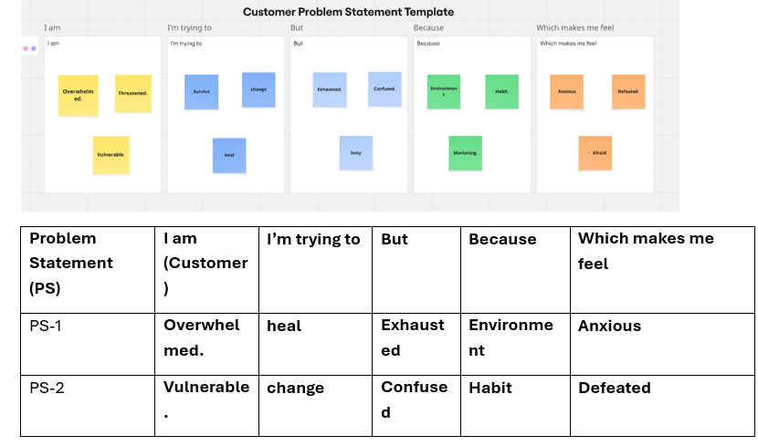
2.2 Empathy Map Canvas:
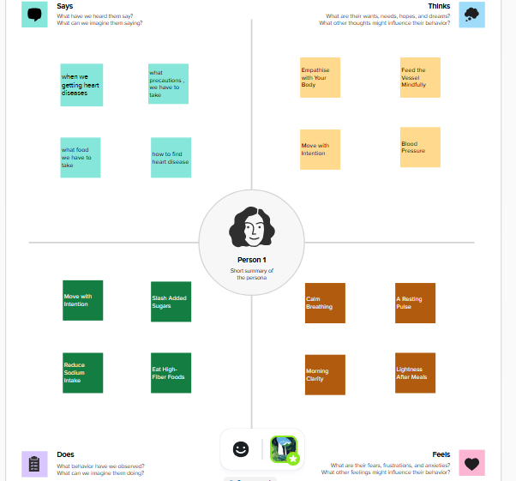
2.3 Brainstorming:
Step-1: Team Gathering, Collaboration and Select the Problem Statement:


Step-2: Brainstorm, Idea Listing and Grouping:

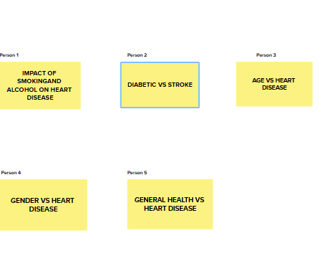

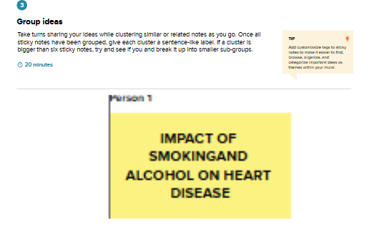
Step-3: Idea Prioritization:
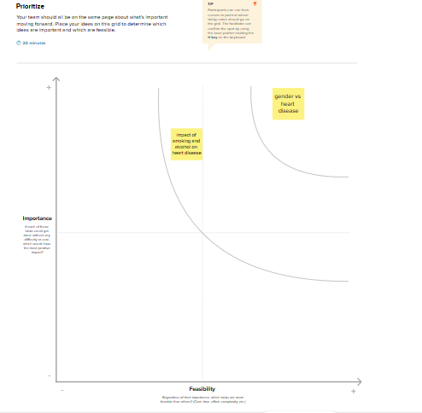
3. REQUIREMENT ANALYSIS:
3.1 Customer Journey map:
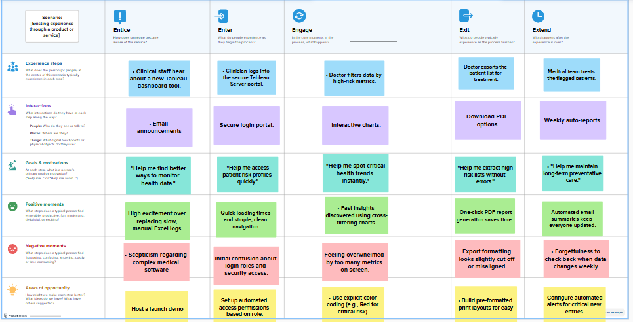
3.2 Solution Requirement:

Functional Requirements:
Following are the functional requirements of the proposed solution.
FR No. | Functional Requirement (Epic) | Sub Requirement (Story / Sub-Task)
FR-1 | Data Integration | As a developer, I need to connect Tableau to the patient cardiovascular database and clean missing values.
FR-2 | Risk Factor Profiling | As an analyst, I want a breakdown of demographic risk metrics like age, gender, and smoking status
FR-3 | Clinical Biometric Analysis | As a clinician, I want interactive scatter plots and distributions comparing blood pressure, cholesterol, and blood sugar.
FR-4 | Interactive Filtering | As a user, I need dynamic dashboard filters to isolate patient metrics by risk level, age brackets, and chest pain types.
FR-5 | Predictive Insight Delivery | As a stakeholder, I want a clear trend-analysis view highlighting early warning indicators to drive preventative health strategies.

Non-functional Requirements:
Following are the non-functional requirements of the proposed solution.
FR No. | Non-Functional Requirement | Description
NFR-1 | Usability | The dashboard must follow clear medical visualization standards, using intuitive layouts accessible to non-technical healthcare users.
NFR-2 | Security | Access to patient cardiovascular metrics must use strict Row-Level Security (RLS) to fully protect sensitive healthcare data.
NFR-3 | Reliability | The backend data extracts must run without failures to ensure clinical metrics remain accurate and up to date
NFR-4 | Performance | Dashboard worksheets and interactive filter actions must load in under 3 seconds to keep clinical workflows fast
NFR-5 | Availability | The hosted Tableau Cloud or Server workbook must maintain a 99.9% uptime during operational hospital hours.
NFR-6 | Scalability | The data model must seamlessly handle an influx of millions of new patient records without degrading visualization performance.

3.3 Data Flow Diagram :
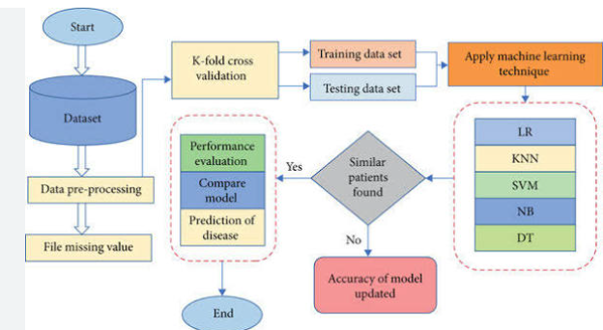
User Stories
Use the below template to list all the user stories for the product.
User Type | Functional Requirement (Epic) | User Story Number | User Story / Task | Acceptance criteria | Priority | Release
Healthcare Analyst | Data Integration | USN-1 | As an analyst, I can connect Tableau to the clinical SQL database securely. | Secure live connection is established with no data loss. | High | Sprint-1
 |  | USN-2 | As an analyst, I can blend demographic tables with biometric lab data. | Patient ID successfully maps metrics across different source tables. | High | Sprint-1
 | Biometric Profiling | USN-3 | As an analyst, I want to see a distribution chart of patient serum cholesterol. | A dynamic histogram showing clean distribution bins of cholesterol. | Medium | Sprint-1
 |  | USN-4 | As an analyst, I want a scatter plot comparing blood pressure against age. | Visual markers correctly isolate clinical risk thresholds. | Medium | Sprint-2
 | Dashboard Assembly | USN-5 | As an analyst, I can create an executive summaries view combining key charts. | All charts display on a single dashboard layout cleanly. | High | Sprint-2

3.4 Technology Stack:
Technical Architecture:
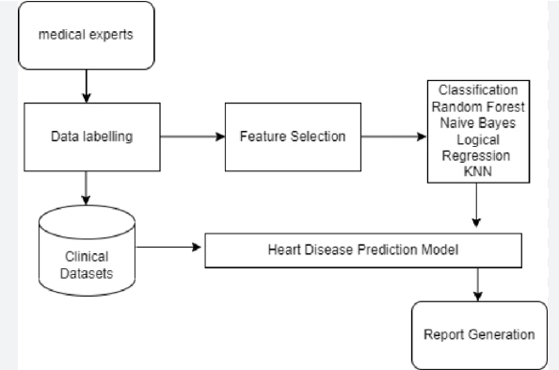
Table-1: Components & Technologies for Heart Disease Analysis
S.No | Component | Description | Technology
1. | User Interface | Clinical dashboard and reporting interface for cardiologists and healthcare administrators to monitor patient metrics. | Tableau Desktop, Tableau Cloud / Server, Web-embedded dashboard portals.
2. | Application Logic-1 | Core ETL pipeline to clean, join, and structure medical records (handling nulls, balancing data, formatting metrics). | Tableau Prep Builder / Python (Pandas).
3. | Application Logic-2 | Analytics extension gateway to pass live dashboard data into predictive pipelines. | TabPy (Tableau Python Server).
4. | Application Logic-3 | Automated natural language narrative generation to explain patient risk anomalies. | Tableau Pulse / Tableau Data Stories.
5. | Database | Structured local/on-premise storage for transactional electronic health records (EHR). | MySQL, PostgreSQL, etc.
6. | Cloud Database | Secure, highly scalable clinical data warehouse for aggregated heart disease research data. | Snowflake, Google BigQuery, or Amazon Redshift.
7. | File Storage | Storage for massive datasets, medical imaging metadata (DICOM logs), or historical CSV records. | AWS S3, Azure Blob Storage, or Local Filesystem.
8. | External API-1 | Real-time clinical lookup to dynamically fetch updated medical coding standards. | ICD-10/ICD-11 Medical Coding API.
9. | External API-2 | National or regional identity registration API to securely pull and verify patient demographics. | Aadhaar API (for India), or localized EHR Integration APIs (FHIR/HL7).
10. | Machine Learning Model | Risk prediction algorithm calculating the probability of cardiovascular disease based on clinical features. | Logistic Regression, Random Forest, or XGBoost model (deployed via TabPy).
11. | Infrastructure (Server / Cloud) | Environment hosting the data pipelines, calculation engines, and dashboard distribution access layers. | Local Configuration: Local Desktop client.  Cloud Server Configuration: AWS EC2, Tableau Cloud, Kubernetes (for TabPy/DB).

Table-2: Application Characteristics
S.No | Characteristics | Description | Technology
1. | Open-Source Frameworks | Core open-source libraries used for data handling, feature engineering, and hosting the live machine learning prediction engine. | Python (Pandas, NumPy), Scikit-Learn (for predictive modeling), TabPy framework.
2. | Security Implementations | Access controls and data protection mechanisms ensuring secure handling of sensitive patient health records. | AES-256 encryption (at rest/transit), Row-Level Security (RLS) in Tableau, HIPAA/GDPR compliance controls, Active Directory/SAML SSO.
3. | Scalable Architecture | Decoupled 3-tier presentation, processing, and storage architecture allowing independent scaling of analytical compute and databases. | Cloud-native analytics architecture using Tableau Cloud/Server, Snowflake data warehouse, and auto-scaling TabPy environments.
4. | Availability | Failover planning and workload management to guarantee clinicians uninterrupted access to critical cardiology data. | High Availability (HA) Tableau Server cluster deployments, multi-region database replication, AWS Elastic Load Balancing (ELB).
5. | Performance | Infrastructure optimization ensuring low-latency dashboard interactions when processing millions of historical patient data rows. | Tableau Hyper In-Memory Data Extracts, pre-aggregated database views, query caching, materialized views in Snowflake.

4. PROJECT DESIGN:
4.1 Problem Solution Fit:
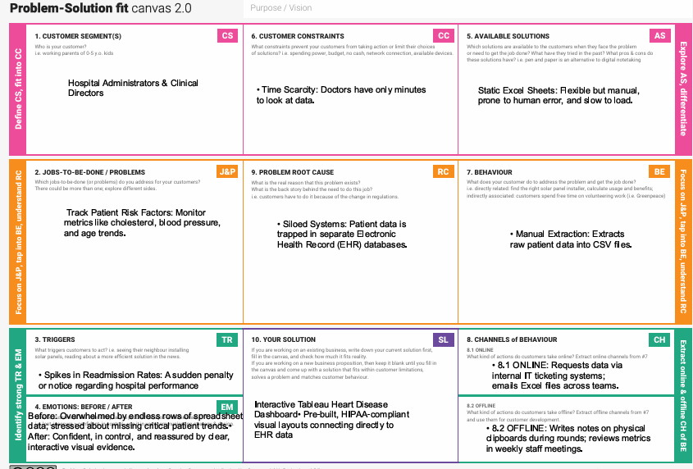
4.2 Proposed Solution:
Proposed Solution Template:
Project team shall fill the following information in the proposed solution template.
S.No. | Parameter | Description
 | Problem Statement (Problem to be solved) | Disconnected, text-heavy clinical records delay critical risk detection and treatment tracking for heart disease patients.
 | Idea / Solution description | An interactive Tableau dashboard aggregating patient metrics into dynamic charts, color-coded alerts, and real-time risk trackers.
 | Novelty / Uniqueness | Replaces dense data rows with instant, two-click visual profiling of multi-variable patient risk factors
 | Social Impact / Customer Satisfaction | Lowers cardiac mortality through proactive care while eliminating manual reporting fatigue for clinical staff.
 | Business Model (Revenue Model) | A subscription-based SaaS model charging annual enterprise or per-user licensing fees to hospital networks.
 | Scalability of the Solution | Uses Tableau’s cloud architecture to expand seamlessly from a single clinic to regional healthcare systems.

4.3 Solution Architecture:

5. PROJECT PLANNING & SCHEDULING:
5.1 Project Planning :
Product Backlog, Sprint Schedule, and Estimation
Sprint | Functional Requirement (Epic) | User Story Number | User Story / Task | Story Points | Priority | Team Members
Sprint-1 | Data Integration | USN-1 | As an analyst, I can connect the heart disease dataset to Tableau and configure the initial data model. | 3 | High | Data Engineer
Sprint-1 | Key Metrics KPI Block | USN-2 | As a clinician, I can view overall patient KPIs for average blood pressure, cholesterol, and age on the main dashboard. | 2 | High | BI Developer
Sprint-1 | Risk Filtering System | USN-3 | As a doctor, I can filter the active patient registry dynamically by demographic details, age group, and gender. | 2 | High | BI Developer
Sprint-2 | Predictive Modeling Visuals | USN-4 | As a medical director, I can view an interactive scatter plot showing patient distribution mapped against multi-variable risk metrics. | 5 | Medium | Data Scientist
Sprint-2 | Patient Trends Monitoring | USN-5 | As a hospital administrator, I can analyze monthly heart disease readmission trends and admission forecasts over a timeline. | 3 | Medium | BI Developer

Project Tracker, Velocity & Burndown Chart (Starting 26 June 2026)
Sprint | Total Story Points | Duration | Sprint Start Date | Sprint End Date (Planned) | Story Points Completed (as on Planned End Date) | Sprint Release Date (Actual)
Sprint-1 | 20 | 6 Days | 26 Jun 2026 | 01 Jul 2026 | 20 | 01 Jul 2026
Sprint-2 | 20 | 6 Days | 02 Jul 2026 | 07 Jul 2026 | 18 | 08 Jul 2026
Sprint-3 | 20 | 6 Days | 08 Jul 2026 | 13 Jul 2026 | 20 | 13 Jul 2026
Sprint-4 | 20 | 6 Days | 14 Jul 2026 | 19 Jul 2026 | 22 | 19 Jul 2026

6. FUNCTIONAL AND PERFORMANCE TESTING:
6.1 Performance Testing:
Model Performance Testing:
Project team shall fill the following information in model performance testing template.
S.No. | Parameter | Screenshot / Values
 | Data Rendered | Title: Heart news  Field:18 fields  Rows:4500
 | Data Preprocessing | -
3. | Utilization of Filters | Age category
4. | Calculation fields Used | -
5. | Dashboard design | AGE VS HEART DISEASE, GENERAL HEALTH VS HEART DISEASE, PEOPLE GOT STROKE SUFFERING FROM DIABETICS AND HEART DISEASE, RACE WISE HEART DISEASE, STROKE VS OTHER DISEASES, IMPACT OF SMOKING AND ALCOHOL ON HEART DISEASE, DIABETIC VS STROKE, PHYSICAL ACTIVITY VS HEART DISEASE
6 | Story Design | AGE VS HEART DISEASE, GENERAL HEALTH VS HEART DISEASE, PEOPLE GOT STROKE SUFFERING FROM DIABETICS AND HEART DISEASE, RACE WISE HEART DISEASE, STROKE VS OTHER DISEASES, IMPACT OF SMOKING AND ALCOHOL ON HEART DISEASE, DIABETIC VS STROKE, PHYSICAL ACTIVITY VS HEART DISEASE

7. RESULTS:
7.1 Output Screenshots:
Dashboards:
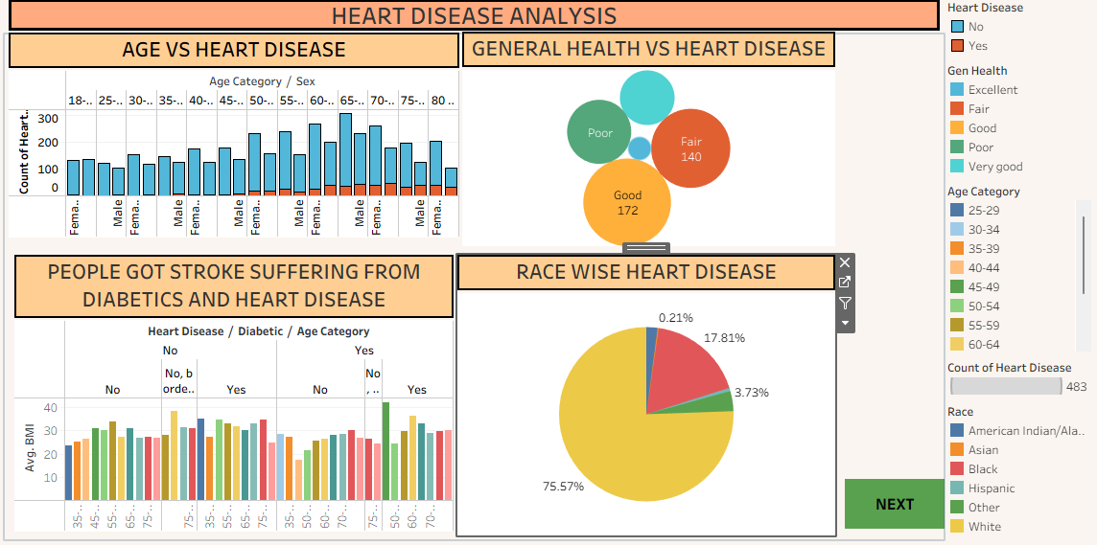
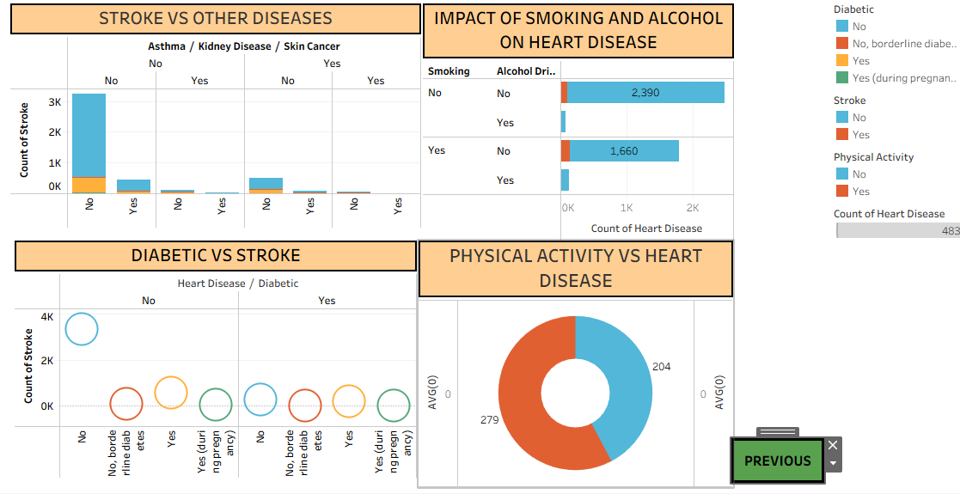
Stories:
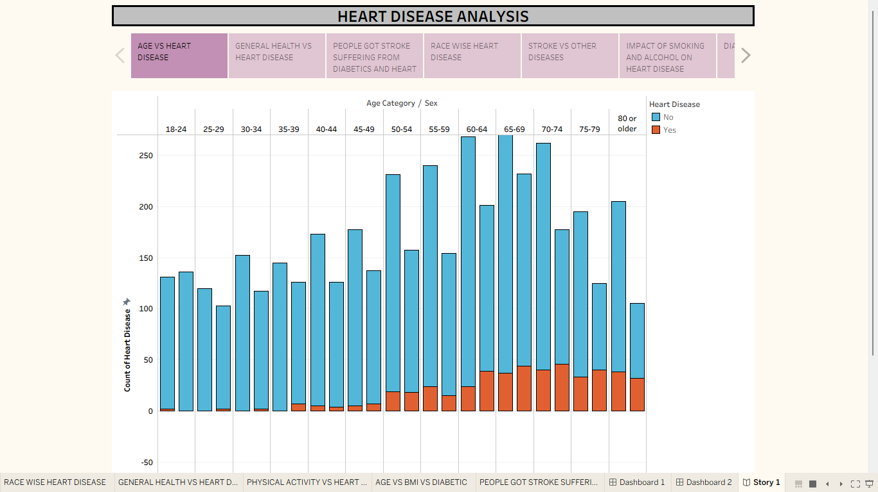
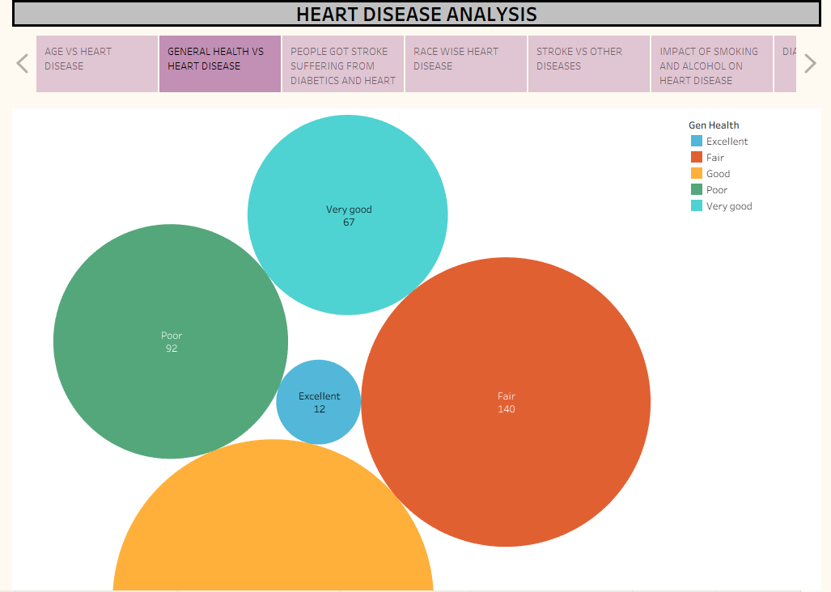
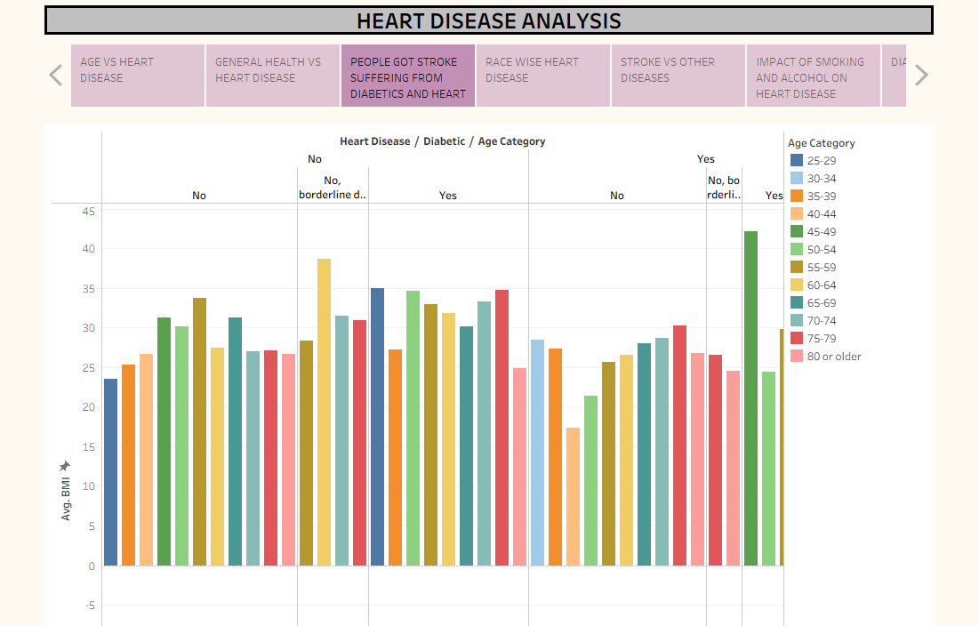
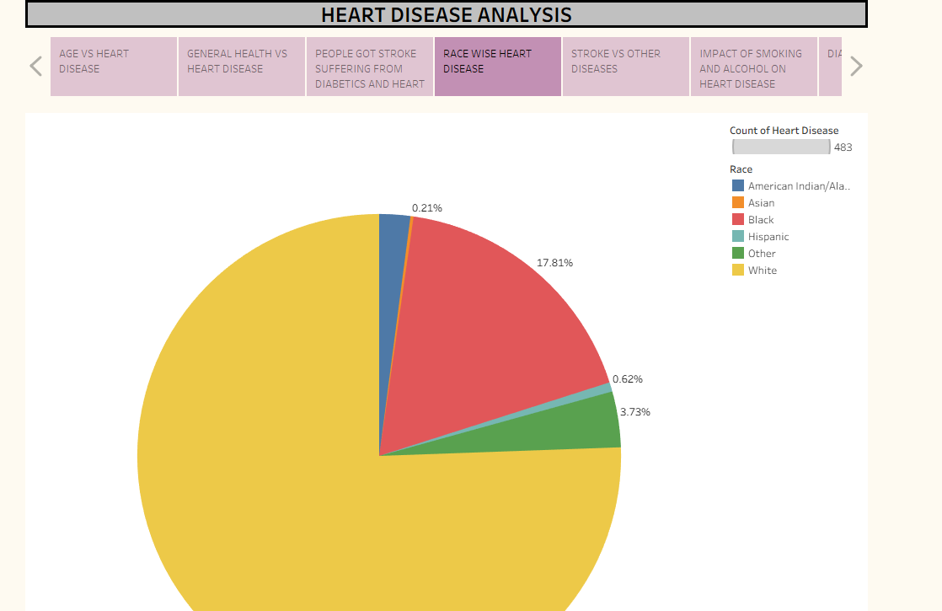
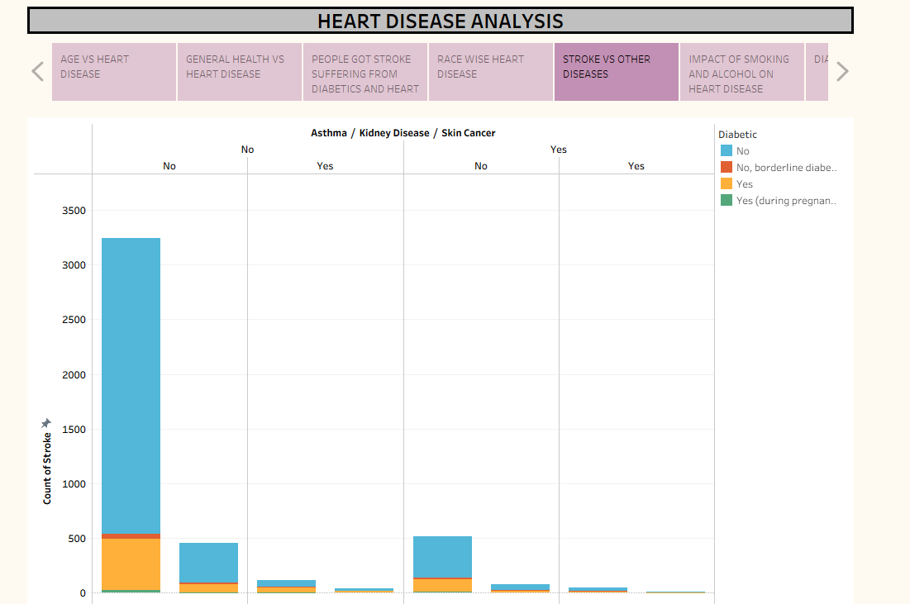
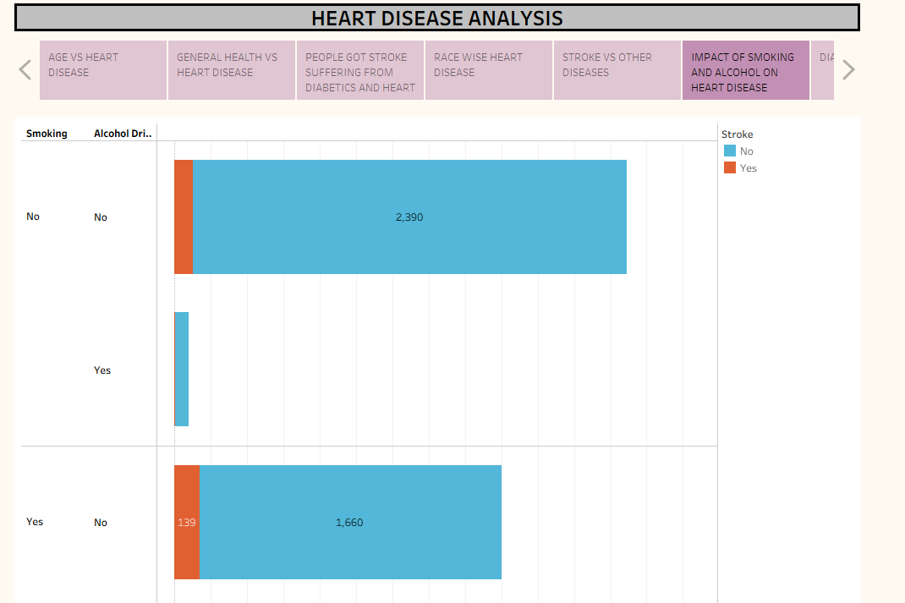
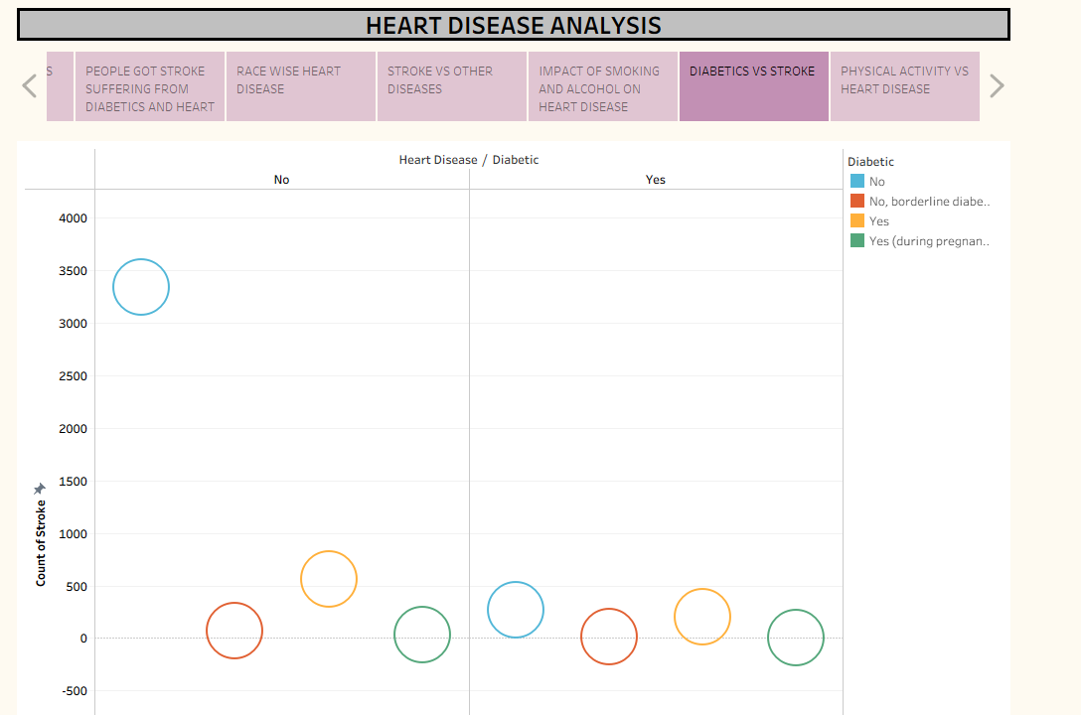
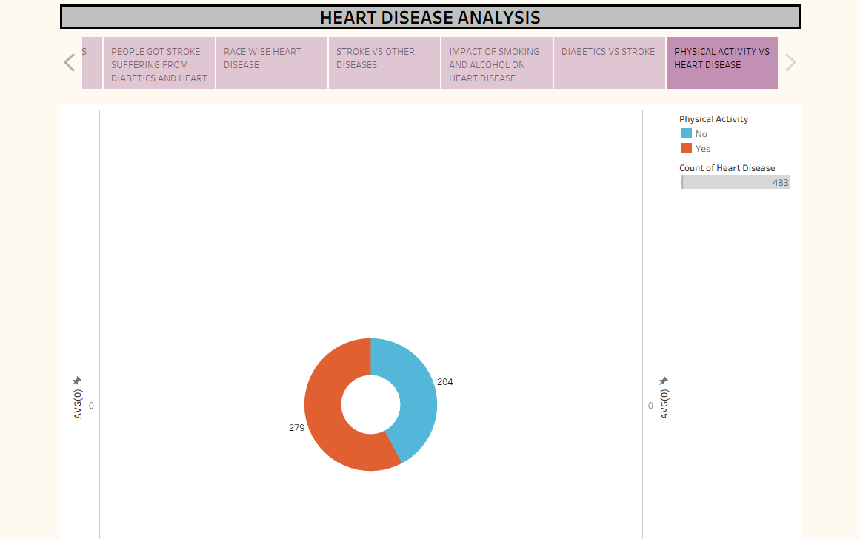

8. ADVANTAGES & DISADVANTAGES:
Advantages of Using Tableau for Heart Disease Analysis
Using Tableau across these three distinct healthcare scenarios provides significant technical and operational benefits:
- Interactive Segmentation: Dr. Sharma can instantly filter complex datasets by age, gender, or smoking habits without rewriting database queries.
- Geographical Mapping: Ramesh can use built-in GIS capabilities to drag and drop regional data, instantly generating choropleth maps to compare rural versus urban disease density.
- Simplified UX for Patients: Anita receives a clean, non-technical interface with color-coded alerts (Red/Yellow/Green) that translate clinical numbers into clear personal goals. [1]
- Rapid Data Ingestion: Tableau connects seamlessly to disparate data sources, linking electronic health records (EHRs), public health census data, and personal wearable trackers. [1]
- No-Code Analytics: Users can construct complex trend lines, correlation matrices, and forecasting models using drag-and-drop actions instead of writing R or Python scripts.
Disadvantages and Limitations of Tableau in this Project
- Despite its data presentation strengths, relying solely on Tableau introduces critical operational, privacy, and analytical risks:
- No Predictive Modeling: Tableau cannot build complex machine learning models; it visualizes historical data but cannot natively run advanced cardiovascular survival or risk-forecasting algorithms.
- Strict Privacy Liabilities: Handling real patient metrics for Dr. Sharma or Anita requires rigorous compliance with healthcare data privacy laws (like HIPAA or local digital health privacy acts). Tableau requires careful server-level security configurations to prevent accidental data leaks
.
- Data Cleaning Dependencies: Tableau assumes your data is already clean. If Ramesh's public health data contains missing entries, duplicates, or poorly formatted fields, Tableau will generate misleading charts.

- High Licensing Barriers: While Anita might use the free Tableau Public application, doing so forces the data to be entirely public. Private clinical or government deployments require expensive enterprise licenses.

- Performance Lag: When analyzing vast, nationwide public health datasets with millions of patient rows, Tableau can experience severe rendering delays unless supported by optimized data extracts or data warehouses.

9. CONCLUSION:
Tableau effectively transforms raw cardiovascular data into actionable insights, enabling targeted clinical interventions, systemic health policy formulation, and proactive individual lifestyle management. The project highlights that visual business intelligence bridges the gap between complex health data and preventive care, with success relying on data privacy, cleaning, and predictive integration. For a deeper understanding of this data visualization project, visit Tableau's documentation and resources
10. FUTURE SCOPE :
Future development of this heart disease analysis project involves transitioning from static visualization to predictive modeling, real-time data integration with wearables, and improved mobile accessibility for personalized care. Planned advancements include implementing AI-driven risk scoring, implementing secure, cloud-based data pipelines, and adhering to strict health data regulations for broader application.

11. APPENDIX:
Source Code(if any) : no
Dataset Link :
https://1drv.ms/x/c/cfceb7a5f4f12416/IQBkwOv1p8BdTpGvWgQyAivzAarxh_xe7-in8lp_KN_t1Ds?e=BcPSsN&nav=MTVfezJCMEU2MkI0LUZGMTktNDNGOS05MTJCLTBBQjNEQjkyQjY1Mn0

GitHub link:
https://github.com/mohammedalisha/HEART-DISEASE-ANALYSIS
https://github.com/snigdhao668

Project Demo Link:
https://drive.google.com/file/d/1_KMDQUXHYb529W9LVT9K5bbXmI5cQyzt/view?usp=drivesdk

